1.Question 1

The first stage of the two-stage design process is _______ design.

Hint: This stage has activities like creating CRC cards, talking with the customer about their requirements, and creating mockups.

**0 / 1 point**

*No answer*

**Incorrect**

2.Question 2

The second stage of the two-stage design process is ________ design.

Hint: This is when you will define the structure of the code and start turning your mockups into classes.

**0 / 1 point**

*No answer*

**Incorrect**

3.Question 3

Which of these conceptual design techniques will help you analyze the problem space to determine classes for your object-oriented software? **Choose the two correct answers.**

**1 / 1 point**



tradeoffs



requirements



CRC

**Correct**

Correct. CRC Cards will help you identify classes.



mockups

**Correct**

Correct. Mockups will help you visualize your problem space in the earliest stages.

4.Question 4

During conceptual design, once the problem is mapped into components, what are the other two critical pieces of information that you must specify for these classes or components? **Choose the two correct answers.**

**1 / 1 point**



responsibilities

**Correct**

Correct. Responsibilities are what the component will do or keep track of.



methods



abstract data types



collaborators

**Correct**

Correct. Collaborators are other pieces of the software that your component will interact with to fulfill its function!

5.Question 5

You are writing the CRC card for a Bear component. Choose the**two** responsibilities.

**1 / 1 point**



eat berries

**Correct**

Correct. Eat berries is something bears are known to do.



den



hunger

**Correct**

Correct. Hunger is not as obvious because it does not have a verb, but you can think of it like this: the bear component needs to keep track of its hunger.



camper

6.Question 6

You are writing the CRC card for a Bear component. Choose the three collaborators.

**1 / 1 point**



den

**Correct**

Correct. A den is a component a bear may interact with.



computer



guitar



tree

**Correct**

Correct. A tree is a component that a bear may interact with.



bear

**Correct**

Correct. Objects can and often do interact with other objects of their class!

7.Question 7

You create an object that represents a**user**, storing important information about them such as their preferences. What kind of object is this?

**1 / 1 point**



entity



boundary



control



client

**Correct**

Correct! Entity objects often represent real-world objects.

8.Question 8

You create an object that represents a **dialog box**. It creates buttons and text fields, etc, for the user to interact with, and it logs those interactions. What kind of object is this?

**1 / 1 point**



control



interaction



entity



display



boundary

**Correct**

Correct! This is a boundary object, because it interfaces with another system (the user)

9.Question 9

You create an object that compares values from two different sources. It then updates the smaller value to be equal to the larger one. What kind of object is this?

**1 / 1 point**



update



control



repository



entity

**Correct**

Correct! This is a control object, because it coordinates the activities of other objects.

10.Question 10

Which of these is an example of a quality tradeoff?

**1 / 1 point**



Adding preferences that allow users to switch some features on and off



Adding security knowing it will reduce speed



Limiting features knowing that they can be added later



Not delivering key features so that deadlines can be met

**Correct**

Correct. A tradeoff happens when to make an improvement you must sacrifice some other quality.

11.Question 11

What is the term for reducing a class or object to its inputs and outputs in modelling?

**1 / 1 point**



pipe thinking



process thinking



black box thinking



filter thinking

**Correct**

Correct! This is called black box thinking, because you don't care what happens inside at this point, only the inputs and outputs.

12.Question 12

Which one of these classes is in most need of being decomposed?

**1 / 1 point**



Student



Book



Store



Order

**Correct**

Correct! A store has lots of responsibilities, including tracking orders, inventory, employees, customers, etc. This class needs to be decomposed.

13.Question 13

In order to provide good encapsulation, fill-in-the-blanks on this UML class diagram: (Replace the underscores _ from top to bottom with minus signs ("-") or plus signs ("+"); your answer will be a string of six + or - signs with no spaces)

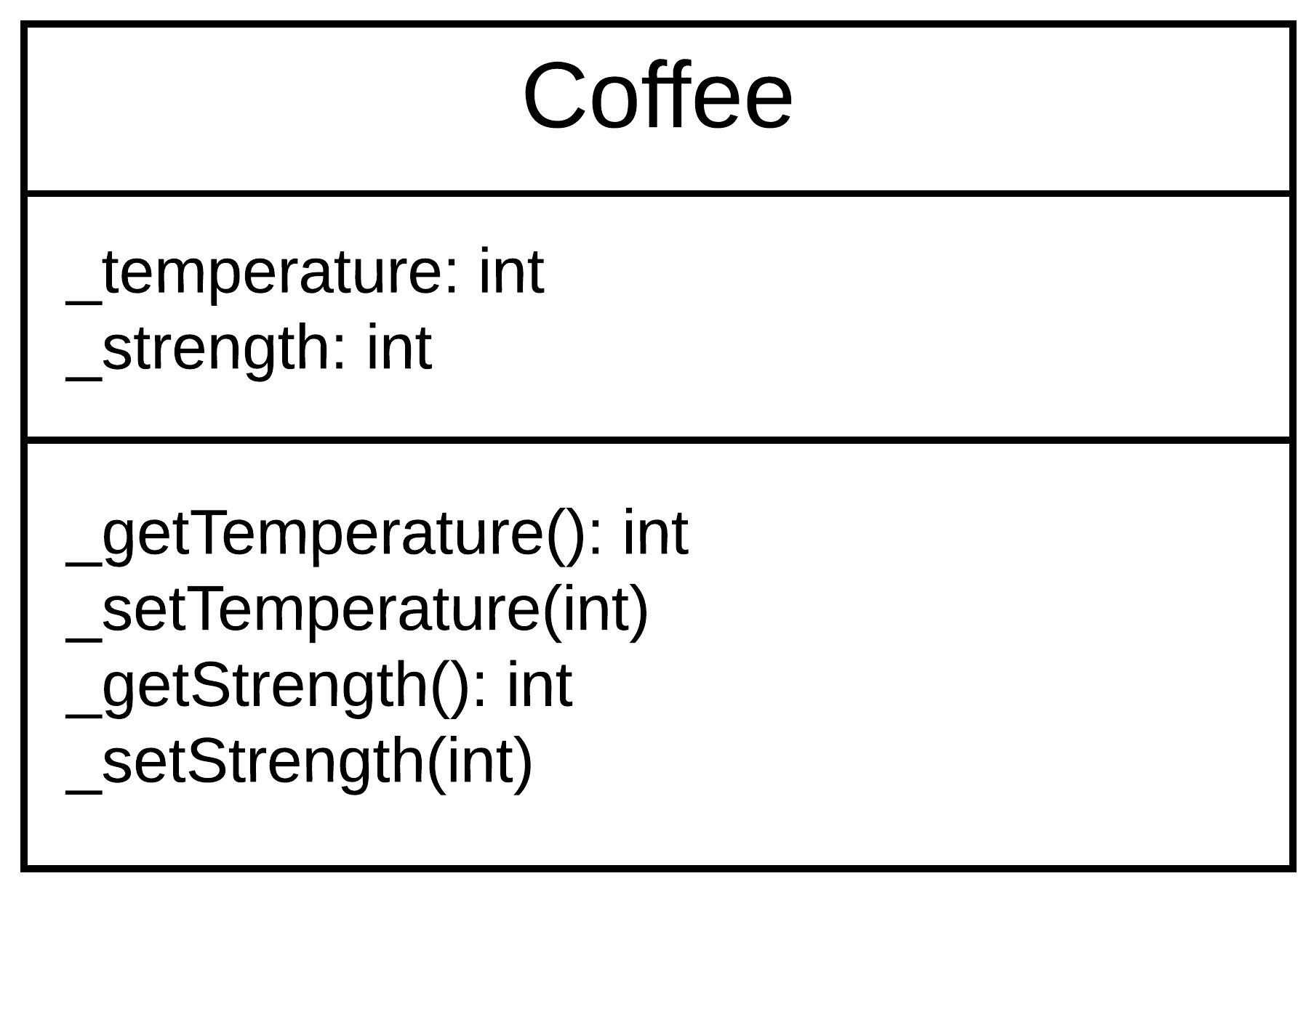

**0 / 1 point**

*No answer*

**Incorrect**

14.Question 14

You are writing a simple soccer video game. Select the best example of proper abstraction:

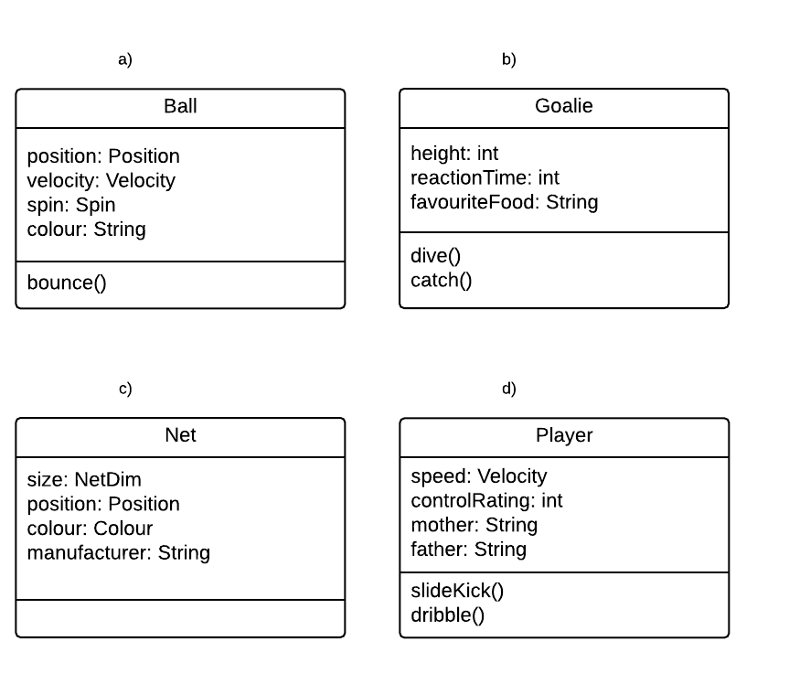

**1 / 1 point**



**a)**



**b)**



**c)**



**d)**

**Correct**

Correct! This class contains only details that are important in the context (a soccer video game).

15.Question 15

Which design principle enables developers to follow the guideline**D.R.Y.** ("Don't Repeat Yourself"):

**1 / 1 point**



encapsulation



decomposition



generalization



abstraction

**Correct**

Correct! Generalization (along with other object-oriented tools) allows developers to follow the D.R.Y. principle!

16.Question 16

Which of these UML class diagrams shows an association relationship?

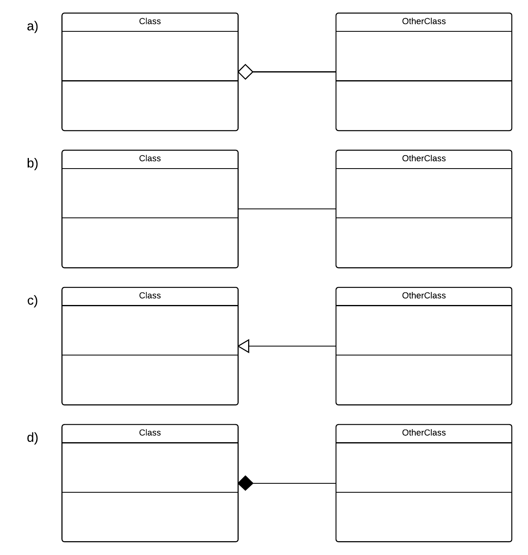

**1 / 1 point**



**a)**



**b)**



**c)**



**d)**

**Correct**

Correct! A simple association relationship is shown with a plain line, often with numbers indicating how many of each object can be associated.

17.Question 17

Which of these UML class diagrams depicts an aggregation ("has-a") relationship between the two classes?



**0 / 1 point**



**a)**



**b)**



**c)**



**d)**

**Incorrect**

You did not choose an option.

18.Question 18

Which of these UML class diagrams depicts a composition, or a strong "has-a" relationship?



**1 / 1 point**



**a)**



**b)**



**c)**



**d)**

**Correct**

Correct! A filled diamond indicates a composition - or strong "has a" - relationship.

19.Question 19

Select the object pairing that has an **association** relationship:

**1 / 1 point**



Book - Page



Tree - Root



Hiker - Trail



Coffee - Water

**Correct**

Correct! The hiker and trailer are associated but not dependent on each other.

20.Question 20

Select the object pairing that has an **aggregation** relationship:

**1 / 1 point**



Car - Road



Book - Page



Stapler - Staple



Pie - Crust

**Correct**

Correct! the stapler and staples can exist independently but usually the stapler aggregates staples.

21.Question 21

Select the object pairing that has a **composition** relationship:

**1 / 1 point**



Book - Page



Bear - Forest



Record Player- Record -



Tea - Sugar

**Correct**

Correct. A book must have pages!

22.Question 22

Choose the **two answers** that correctly complete the following sentence:

**"We say that a class has low cohesion if..."**

**1 / 1 point**



...connects to many other classes.



...it does not have all the necessary parts, i.e. it is incomplete.



...its purpose is unclear.

**Correct**

Correct. Cohesion is how well a class is directed toward a clear, singular purpose.



...it tries to encapsulate too many unrelated responsibilities.

**Correct**

Correct. Cohesion is the degree to which a class is directed toward one purpose. Giving it unrelated responsibilities reduces cohesion.

23.Question 23

Two classes are tightly coupled. What are some ways you might be able to tell? **Choose the two correct answers.**

**1 / 1 point**



In order to understand one class, you need to open up the other to look at the implementation

**Correct**

Correct. This is usually a sign that the coupling is too tight; instead, the interfaces should be clear and interactions limited.



Their interactions are limited and controlled



They can easily be swapped with different implementations of the same class



They are very highly reliant on each other

**Correct**

Correct. Coupling refers to how deeply integrated different components are. Tight coupling means the components are deeply integrated, which is not desirable because it makes it more difficult to make changes.

24.Question 24

How can you apply the principle of Separation of Concerns in object-oriented programming?

**1 / 1 point**



Separate objects or components according to their role in the software



Ensure classes are only concerned with their own data



Split developers into teams that each deal with different parts of the software



Separate data and actions (methods) into different classes

**Correct**

Correct! Each object or component should have a fairly specific role or concern in the software which is separate from the concerns of other objects.

25.Question 25

Which of these violates **Liskov's Substitution Principle**?

**1 / 1 point**



the superclass is too general



an operation in the superclass is replaced by a different operation in the subclass



subclasses specify the abstract methods of the superclass



the subclass adds behaviour

**Correct**

Correct! This directly violates Liskov's substitution principle, which is a useful test to identify poor uses of inheritance.

26.Question 26

For which of these situations would you use a sequence diagram?

**0 / 1 point**



To show the different modes that your program can be in.



To show the collaborative behaviour of objects in your program.



To show the relationship between classes



To show all of the different processes of your program.

**Incorrect**

Incorrect. This is a job for Class diagrams

27.Question 27

Choose the correct state diagram for a car which has a state called "HasGas:"

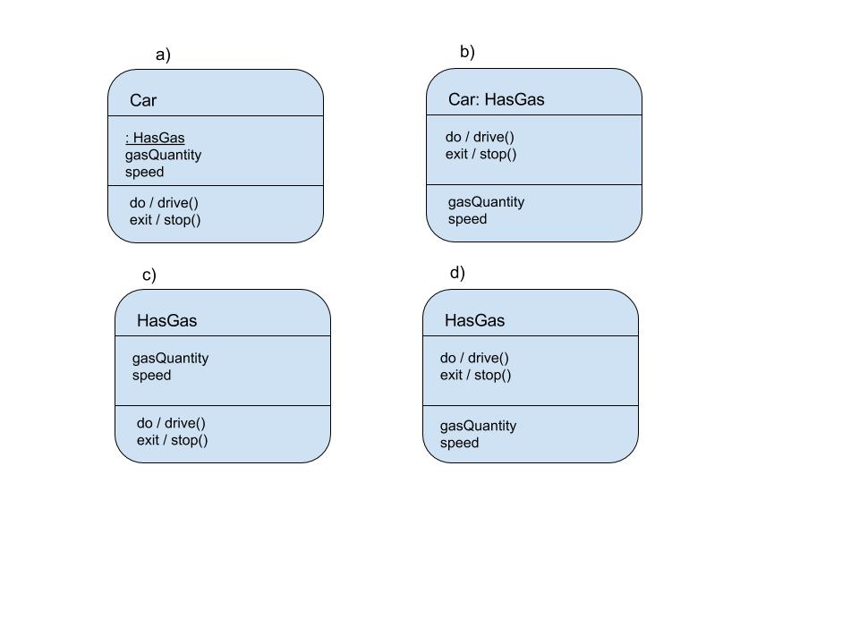

**1 / 1 point**



**a)**



**b)**



**c)**



**d)**

**Correct**

Correct! The state goes at the top, variables in the middle, and activities (including exit and entry activities) in the bottom.

28.Question 28

Which of these elements represents a termination in a UML State diagram?

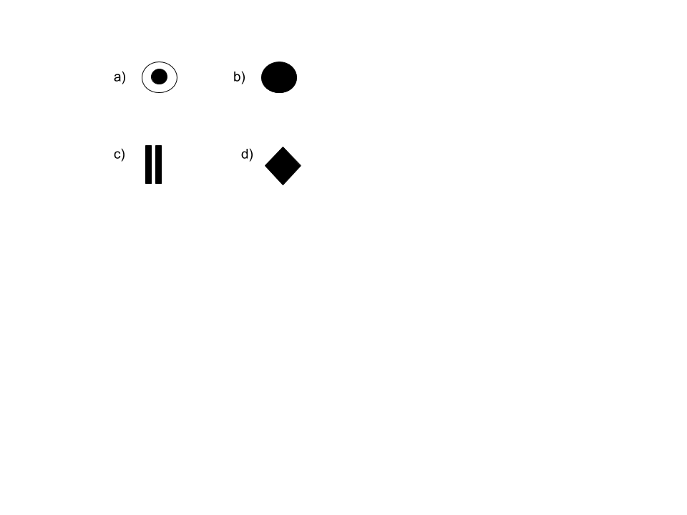

**1 / 1 point**



**a)**



**b)**



**c)**



**d)**

**Correct**

Correct! This represents a termination

29.Question 29

What is the purpose of model checking?

**1 / 1 point**



To verify that the technical implementation matches conceptual mockups



To check the software for errors before release



To test for user-reported bugs



To verify that the conceptual model of your software matches the customer's requirements.

**Correct**

Correct! this is the point of Model Checking.

30.Question 30

What is an abstract data type?

**1 / 1 point**



a data-centric class



a data type that cannot be used directly but must be implemented as an interface



a type of data defined by the developer rather than the language.



variables that are assigned a type (i.e. integer, double) but does not yet have a value assigned.

**Correct**

Correct! Abstract data types are structured by the developer. They eventually evolved into classes.